G VENKATA SRIDHAR  gvsridhar.devops@gmail.com
+91-9739964629

GIT

What is GIT?
- GIT is a Tool, mainly used for Version Control System [VCS] or Source Code Management [SCM].
- VCS | SCM - To maintain multiple versions & to track different versions of a File or Directory.
- Type of files track by VCS - html, .jsp, .java, .properties, PHP etc.
- Type of files not tracked by VCS - Images, Audio & Video Files.
- GIT supports on Windows | MAC OS | Linux.
- CVS - Track Multiple Files & Multiple Directories but allows only one user at a time.
- SVN - Track Multiple Files & Multiple Directories also allows multiple users. (Centralized Version Control System).
- GIT - Track Multiple Files & Multiple Directories also allows multiple users. (Distributed Version Control System).

Differences between SVN & GIT?
SVN | GIT
Centralized Version Control System | Distributed Version Control System
Back-Up need to take on Server | Back-Up need to take any Client System
Client & Server based system | Every Project is independent
Very hard to find Errors in SVN | Very easy to find Errors in GIT
More Disk Space & Low Performance | Less Disk Space & More Performance
SVN always need Internet Connection | GIT wants Internet when we move Central Repo

How to download & install GIT?
- To install GIT, click on this link https://git-scm.com/downloads. Download as per your OS and install. After installing GIT, open GIT Bash by Right Clicking.
- Check whether the GIT successfully installed or not.
- git --version
- Create a new folder and enter into that dir. First, we need to initialize the GIT repository.
- mkdir extra / cd extra
- git init (Initialize GIT and create empty structure under .git folder in E:/GIT/.git)
- tree .git (Shows all hidden folders in .git)
- git status

How to Configure GIT to work correctly?
- 3 types of configurations
- System ( /etc/gitconfig )
- git config –system
- User ( ~/.gitconfig or /home/xyz/.gitconfig )
- git config –global
- Project ( .git/config )
- git config
User Level Configuration
- After that we need to configure user name and email id
- git config --global user.name "Sridhar"
- git config --global user.email "gvsridhar2050@gmail.com"
- git config --global user.email core.editor “Sridhar”
- git config --global user.email color.ui “vim”
- git config --list ( Here we can list all configurations )

NOTE: (UserName & Email provided by company in Real-Time)

- Create some sample files by using Touch or vi (Editor) or Cat commands
- Example: Touch file1 || vi file2 || cat > file3

How to install GIT in Linux?
- yum install git -y ( If you are ROOT )
- sudo yum install git -y ( If you are not as ROOT )
- sudo yum –y install java

GIT - Project Development Process
Step 1: First, we need to create a directory, command to create a Directory
- mkdir “DirectoryName”

Step 2: Main Purpose of using GIT
- Now I am using GIT to track above created Directory.

Step 3: We need to initialize GIT.
- git init

Step 4: Phases in GIT

GIT having three phases or stages:

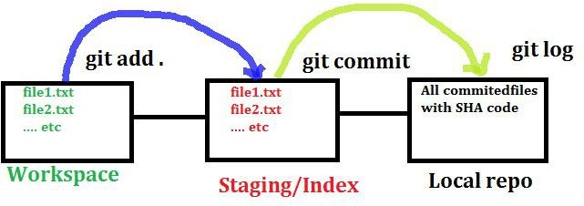
- Workspace Area | Working Directory.
- Staging Area | Index Area | Cache Area.
- Local Repository | GIT Directory.
Working Directory: In this phase, it does not track the files. To track the files, we have to commit these files by first adding the files to the Staging Area. This brings us to the next stage in GIT Life-Cycle.

Staging | Cache Area: In this phase, source code files, data files, configuration files and other project artifacts all these files are to be tracked by GIT and added to the staging area.
In other words, in Staging Area we add and organize the files to be committed to GIT for tracking their versions.
- git add filename (or) git add .

Local Repository: In this phase, added files in GIT will be committed and along with commit message. Once committed, these files now eligible to move from Local Repo to Central Repo.
- git commit –m “Commit Message” (We can add this message from JIRA Description).

- When we are creating the files it will be under ( Workspace Area | Working Directory )
- git status (Now it will show all files in workspace). All workspace file names in Red Color
- git add filename || git add . ( Here “.“ indicates all files in Workspace Area)
- Git status (Now it will show all files in Staging). All index/staging area files in Green Color
- git commit -m "commit message" - All files committed from Index Area to Local Repository
- git status (here it showing nothing to commit, working tree clean)
- git log (This command will displays all log files (or) to see commit messages)
- git log --oneline
- git log --since=2018-07-05
- git log –until=2018-07-05
- git log --author=”Sridhar”
- git log --grep=”file1”
- git log --oneline --author=”Sridhar” --grep=”file1”
- git diff <sha1 number1>..<sha1 number2> → we can see differences between 2 commits.

What is SHA1 Number?
- It is a random and unique 40 character Hexa Decimal Value ( 0-9, a-f )
- git show <sha1 Number> (This command is to see the content of a COMMIT)

What is Branch?
- It is a series of COMMITS along with the Files/Directories.
- git branch (It shows all the current branches in Alphabetical Order).
- *master or *feature - (Here * represents you are currently in that branch)

How to create Branches
- By default Branch name is MASTER
- git branch ( To list all Branches )
- git branch “BranchName” ( Ex: git branch xyz )
- git branch --list || git branch
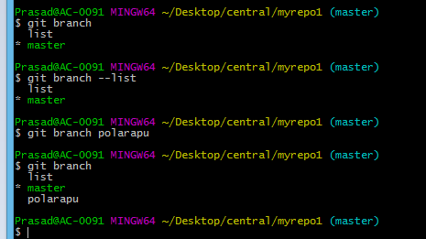

How to switch newly created branch
- git checkout “BranchName” ( Ex:- git checkout sridhar )
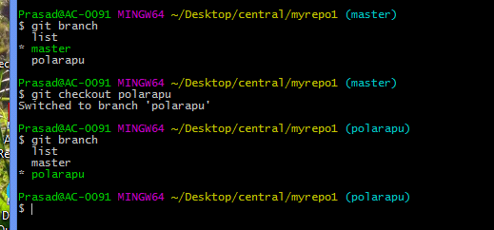
- Now we are in sridhar branch, please observe the below figure.

How to delete a Branch
- Before deleting branch we need to switch to different branch
- git checkout master
- git branch
- git branch -d “BranchName” ( Ex:- git branch -d sridhar ) – Normal Delete
- git branch -D “BranchName” ( Ex:- git branch -D sridhar ) – Forcible Delete
- git branch -d “branch name” — Delete from Local
- git push origin —delete “branch name” — Delete from Remote
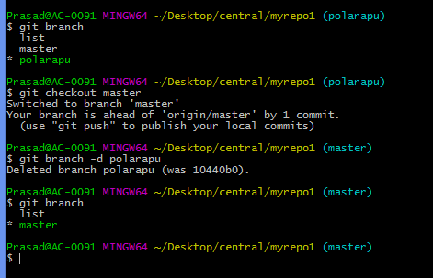
How to create Branch and How to switched branch with in single step
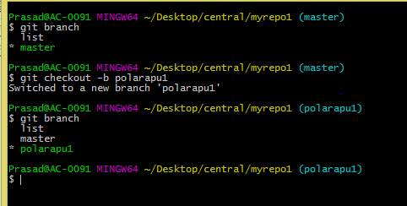
- git checkout -b “New BranchName” ( Ex:- git checkout -b sridhar1)

How to create New File?
- touch <FileName> → touch file1.txt/file1.html
- echo “this is file1”>file1.txt → To Add content to the above file.txt we use ECHO
- git status
- git checkout extra → To Swap between branches etc., we use CHECKOUT

What is Merging?
- Mixing of two Branches is called Merging. We need to have two Branches for Merging.
Master (Target) ----- Feature (Source)
- git merge feature
- git commit -a → To Mention Conflicts

- git branch
- git branch “New BranchName”
- git checkout “BranchName”
- git checkout –b “New BranchName”
- git diff “Branch1”.. “Branch2”
- git merge “BranchName”
- git branch –d “BranchName”
- git branch –D “BranchName”

- Now create number of files in two branches with different names
- git checkout sridhar1 ( Switch into 1st Branch )
- Create some files here like file1.txt, file2.txt, etc. Do GIT (Add and Commit)
- git checkout sridhar2 ( Switch into 2nd Branch )

- Create some files like file5.txt, file6.txt, etc. Do GIT (Add and commit).
- Now switch into sridhar1 branch (1st Branch), please observe in below screenshot.
- git checkout sridhar1
- git merge “Other BranchName” ( Ex:- git branch sridhar2)

NOTE: When we are deleting any branch, we should be in MASTER Branch.
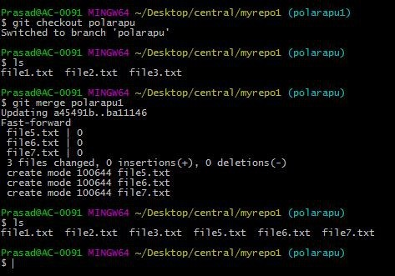
How to Create & Checkout Branch in One Line?
- git checkout -b “New BranchName” → git checkout –b feature1

How to see differences between two branches?
- git diff “Branch1”.. “Branch2” → git diff master..feature1

How to Add & Commit files/directories in single step?
- git commit --am “Commit Name” → git commit –am “Add & Commit in Single Line”
NOTE: This command is applicable only for existing files.

How to change COMMIT Message?
- git commit --amend -m “Commit Message” → git commit --amend -m “Latest Message”
NOTE: This command is applicable only for existing files.

How to change COMMIT Message and Add Modified Files?
- echo “new line in f1”>>f1
- git status
- git commit --amend -m “File added & file modified” f1
- git commit --amend -m “Commit Message” <FileName>
- git commit --amend -m “Commit Message with modified file” file1

How to get back deleted file?
- rm <FileName> → rm file1 (This file will delete only from Working Directory i.e. 1st Phase
- git status → Shows the deleted file.
- git checkout <FileName> → git checkout file1

How to delete a file permanently from all 3 phases?
- git rm <FileName> → git rm f2
- git status → Shows the deleted file.
- git commit -m “f2 Deleted”
- git log --oneline
- This file will deleted permanently from all 3 Phases & we cannot even retrieve it back.
How to rename a file in GIT?
- mv f3 f5
- git mv <FileName> <Rename FileName> → git mv f5 f3
- git status
- git commit -m “f5 Renamed as f3”
- git show “Please enter 6-Digit Sha1 Number” → git show a6789de

How to Add file forcibly even if it is ignored in GIT?
- git add -f b.php
- git status

How to ignore unwanted files in GIT?
Project Level: vi .gitignore
*.log *.obj *.jpeg *.png *.php *.class !index.php
- ls -a (Shows all the hidden files that starts with dot (.))
- git status
- git add .
- git commit -m “Ignore File Added”
- touch Hello.php
- git status → does not show Hello.php because the extension .php was ignored.
- touch index.php
- git status → It will show in status because it is allowed in ignore file.

How to erase your history in GIT?
- git reset --soft <Sha1 Number> → git reset --soft 7abrg4f2 (6-Digit Sha1 Number)
SOFT erases the history only from Local Repository

- git reset --mixed <Sha1 Number> → git reset --mixed 7abrg4f2
MIXED erases the history from Local Repository + Staging Area

- git reset --hard <Sha1 Number> → git reset --hard 7abrg4f2
HARD erases the history from Local Repository + Staging Area + Working Directory
*Should not use in real-time because it will erase history as well as added files also.

What is HEAD in GIT?
- Head is a pointer, which points to the Top Commit
- git reset --hard 7abrg4f2
- git status
- git log –oneline

What is STASH in GIT?
- STASH is a temporary area under GIT.
- To store temporary files we use STASH.

How we use STASH in GIT?
Conditions to store temporary files in STASH AREA.
- The files must and should be in CACHE Area | Staging Area.

Commands used to in STASH.
- Examples:
- git stash save <”Message”> → Used to STORE the data in STASH
- git stash list → Used to see STASH List ( stash@{0}: <BranchName> <Message> )
- git stash apply <stash#> → Used to COPY the data into branches in STASH
- git stash pop <stash#> → Used to CUT the data into branches in STASH
- git stash drop <stash#> → Used to DELETE the particular STASH
- git stash clear <stash#> → Used to DELETE the entire STASH List

NOTE: Stash# → Stash0 (Can contain 0…100 files), Stash1 are called Revisions.
- Examples:
- git branch
- git checkout master
- git stash apply stash@{0}
- git status
- git stash list
- git stash pop stash@{1}
- git stash list
- git stash drop stash@{0}
- git stash clear
- git stash list

How to install GIT Server?
- GitHub is a Public GIT Server
- Git Bucket | Bit Bucket are Private GIT Servers. (Pre-Requisite - Java Required)
- Download Git Bucket (gitbucket.war), right click and copy link address
- In Linux Terminal/Putty → wget “paste the gitbucket.war copied link”
- Next Command → java -jar gitbucket.war --port=9090

GIT Bucket Server Side Setup
- Login to GIT Bucket Interface
Default → user: root & password: root
- Go to user profile and change password if you want to.
- To create user, go to administration create users.
Remote Repository: Same as Local Repository

GIT Bucket Client Side Setup
- Setup remote in the Client Side
- git remote add <AliasName> <url>

- To create user, go to administration create users.
- git remote → To see remote repo name.
- git remote -v → To see entire URL of remote repo.
- git remote rm <AliasName> → To remove a Remote Server.
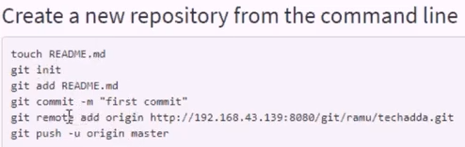

How to push the data into Remote Server?
- git push -u <AliasName> <BranchName> → To push data into Remote Server.
- git push -u origin master

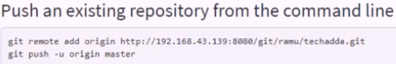

- Now the changes will move/push to Master (Local Repo) → Master (Remote Repo)

How to pull the data into Remote Server?
- Method 1: Fetch & Merge
- git fetch → Download data from Remote Server to Local Repository.
- git merge origin master → Downloaded data to be shifted to any branch, we use MERGE

- Method 2: Pull
- git pull → It will automatically download the files & fetch
- git pull <AliasName> <BranchName> → It will automatically download the files & fetch
- git pull origin master
- git merge origin master

GIT Clone
- git clone is used to create a copy of a target repo
- git clone <Repo> <Directory> → Cloning a Local or Remote Repository
- git clone -c core.longpaths=true git@code.devops.fds.com:CAP/OrderDomain.git
(For Master branch)
- git clone -c core.longpaths=true -b FEATURE/RISK-97 git@code.devops.fds.com:CAP/OrderDomain.git (For any feature branch).

How to create GITHUB Repository
- Create a GITHUB Account, Login to https://github.com/
- Click on start project option see the below snapshot
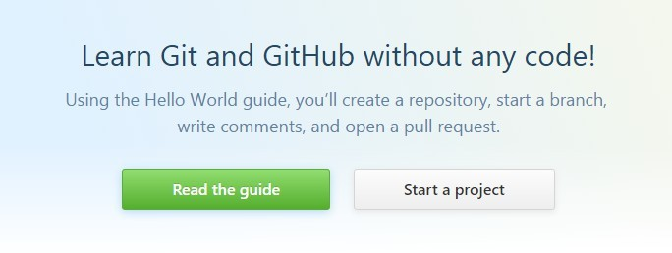

- Give the repository name and click on initialize this repository with a README
Click on Create repository as shown below.
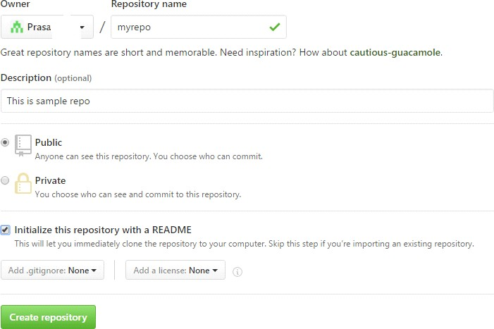
- Click on Clone or download tab and copy the path
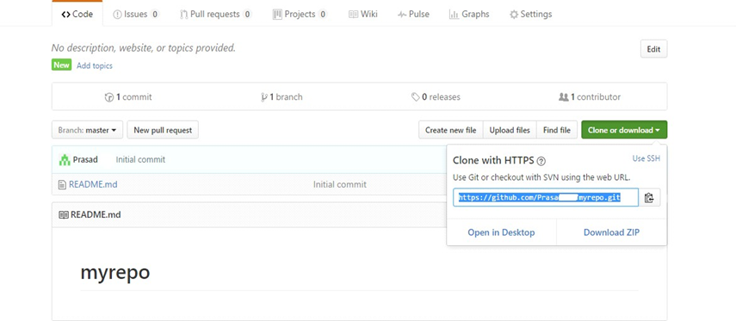

- Now open GIT, Create a new folder like CENTRAL and enter into Central Directory
- git clone path/of/github/repository
- git clone https://github.com/Prasadxyz/myrepo.git
- Enter into myrepo directory, now here create some sample text files, all files Add and Commit.
- git push path/of/github/repo Branch name
(By default Branch name is MASTER)
- git push https://github.com/Prasadxyz/myrepo.git master, now go to github and refresh it, here it will displays all files.

GIT Installation on MAC/WINDOWS & Create GITHUB Account
Step 1: Check if git is already installed.
- terminal → git --version
Step 2: For Windows - Download .exe and install git
For MAC - https://git-scm.com/download/mac
Step 3: Signup and create an account on GitHub
- https://github.com/
Step 4: Add your github email and username to git
- git config --global user.email "yourGitHub@email.com"
- git config --global user.name "yourGitHubusername"
Step 5: Add file/folders to git - tracking
Step 6: Commands
- terminal - goto the location of the folder/project
- git init
- git status
- git add
- git commit -m “commit message”
- git remote add origin “location of remote repo”
- git push -u origin master
- git log
- git –help

Enable git commands AutoComplete & Color features on MAC OS
For enabling GIT AutoComplete
Step 1: goto terminal
put git-completion.bash script in your home directory
url https://raw.githubusercontent.com/git... -o ~/.git-completion.bash
Step 2: Add following line to your .bash_profile.
This tells bash to run git autocomplete script if it exists

vi ~/.bash_profile
if [ -f ~/.git-completion.bash ]; then
. ~/.git-completion.bash
fi

For enabling GIT Colors
Step 1: Check if coloring is already enabled
- git config color.ui
Step 2: Enable Coloring
- git config --global color.ui true

How to enable E-Mail Services using GITHUB
- Actually, email services are replaced and new options introduced in latest git version.
- The new option is Github → Repository → Settings → Notification → Add your EMail-ID
- To trigger notification email from github, whenever there is any change/commit in the project

Step 1: Github → Repository → Settings → Integration & Services →
→ Add Email-ID
Step 2: Test and validate by making some change in the project

How to Create Tags in GIT/Releases?
Step 1: Checkout the branch where you want to create the tag
- git checkout "branch name"
- Example : git checkout master
Step 2: Create tag with some name
- git tag "tag name"
- example : git tag v1.0
- git tag -a v1.0 -m "ver 1 of .." → To create annotated tags
Step 3: Display or Show Tags
- git tag
- git show v1.0
- git tag -l “v1.*”
Step 4: Push tags to remote
- git push origin v1.0
- git push origin --tags
- git push --tags → To push all tags at once
Step 5: Delete Tags (if required only)
To delete tags from Local:
- git tag -d v1.0
- git tag --delete v1.0
To delete tags from remote:
- git push origin -d v1.0
- git push origin --delete v1.0
- git push origin :v1.0
To delete multiple tags at once:
- git tag -d v1.0 v1.1 (local)
- git push origin -d v1.0 v1.1 (remote)

Creating TAGS from past commits
- git tag "tag name" "reference of commit"
- example : git tag v1.2 5fcdb03

GIT Merge Vs GIT Rebase
- In Git there are 2 ways to integrate changes from one branch to another
git merge
- - Is a non-destructive operation
- - Existing branches are not changed in any way
- - Creates a new merge commit in the feature branch
git rebase
- Moves the entire feature branch to begin on the tip of the master branch
- Re-writes the project history
- We get much cleaner and linear project history

How to create github repository, clone repository in eclipse, add eclipse project to github repository & commit, push and pull the changes
Step 1: Create GitHub account and SignIn
Step 2: Start a Project = Create a repository
Step 3: Start Eclipse
Step 4: Goto Perspective - Git Repositories and click on Add Git Repo
Step 5: Create a project in Eclipse
Step 6: Do a right click on Project - Team - Share - Add to git repo
Step 7: Commit and Push the project to the repo
Step 8: Commit and Push every change to the repo

GIT BASIC COMMANDS
git config --list | git push origin master | git branch newname
git config --global user.email | git log | git checkout branchname
git config -- global user.name | git show | git checkout –b branchname
git config --global --list | git reflog | git checkout –d branchname
git clone url (GIT HUB) | git rm filename | git checkout –D branchname
git init | git commit –-amend | git remote
touch filename | git pull origin master | git remote rename
vi filename | git rm –f filename | git remote rename <old> <new>
git add file name | git diff | git remote show origin
git add . (Adding all files) | git branch | git remote -v
git status | git branch -a | git branch –m <old> <new>
git commit –m “message” | git branch -r | git push origin branchname
git merge sridhar | git tag –d xyzversion.1 | git pull origin branchname
git pull –rebase | git show xyzversion.1 | git remote show origin
git tag | git tag –a ‘zyxversion.1’ | git revert
git tag -l | git push origin tag xyzversion.1

GIT WORKFLOW
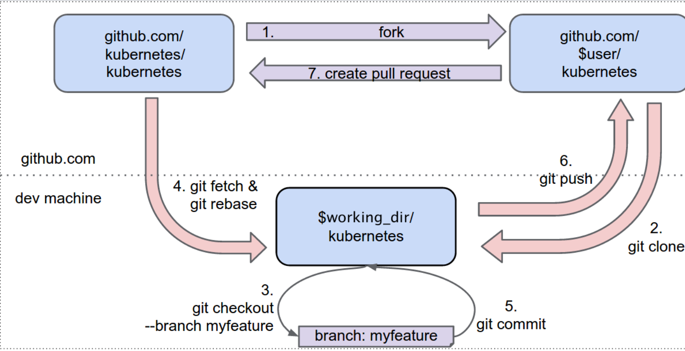

GIT CONCEPT
